HUMAN RESOURCE MANAGEMENT SYSYTEM

PROJECT DOCUMENTATION

**Project Description**

The HRMS is aimed to track the attendance of rented labors from different companies. It has a login system for the admin. The admin can add new companies, projects, employees and trades. It also has a notification system regarding the expiry dates of employee details like visa, passport, emirates id, and workmen compensation. The admin can easily generate an attendance report based on a company.

**Functional Requirements**

* Xampp / Lamp / Wamp with PHP version 7 or above.
* Composer

**Project Installation**

1. Open the folder C **-> xampp -> htdocs** and copy the project.
2. Run Xampp by clicking on the application.
3. Start Apache and MySQL
4. Open the command Prompt and enter the commands.

* Go to your project folder by entering the commands below.

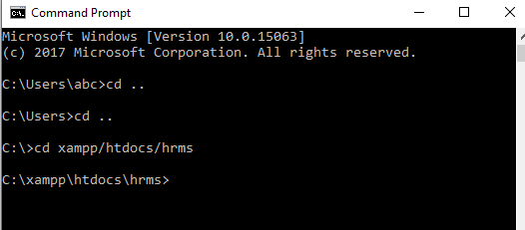

* Now, Run these commands

***php artisan migrate***

***php artisan db:seed***

**How to Run the Project**

1. Run Xampp
2. Start Apache and MySQL
3. Open Command prompt , go to the project folder as above and run the command

***php artisan serve***

1. Copy the link address http://127.0.0.1:8000/ and paste in the browser address bar.

**Login**

The admin can login to HRMS by a predefined password and email address. The admin can change the login credentials once logged in.

**Usage**

The usage of each page is detailed in this section:

1. Login Page

The admin can login with a predefined email address and password and can edit the login credentials once logged in.

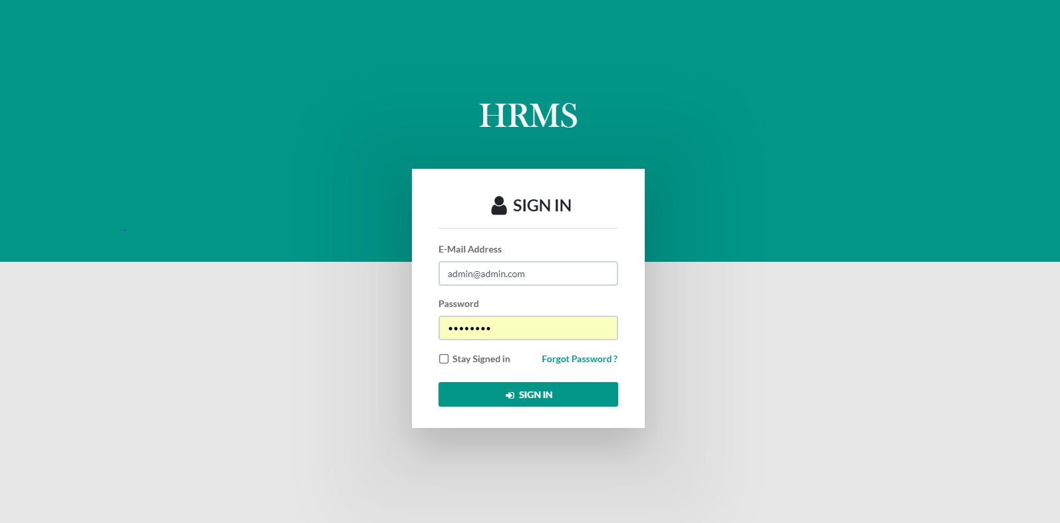

1. Admin Home Page

After Login, Admin enters to the home page where he can manage all the activities. In the navigation bar, the bell icon shows the unread notifications. The user icon will direct to Edit Profile Page where admin can update his/her details and password.

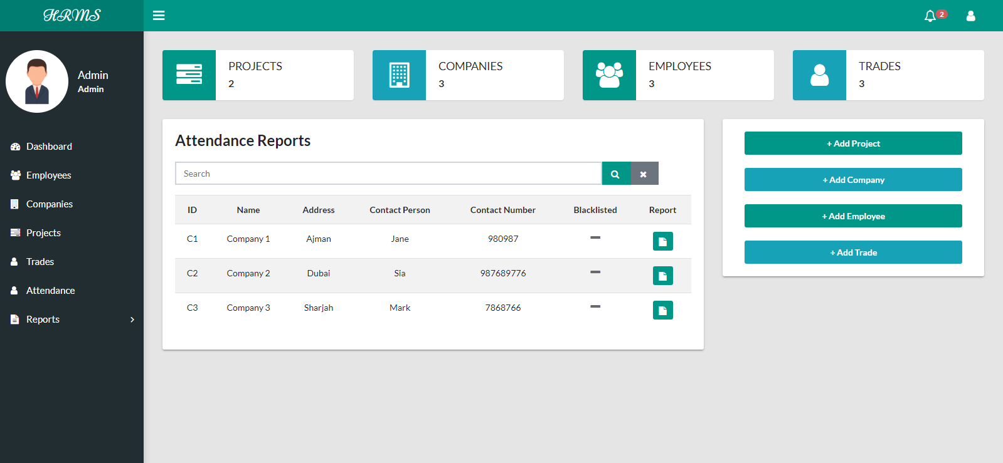

1. Notification Icon

Unread notifications will be shown here. On clicking ‘see all notifications’ the user can see all the notifications.

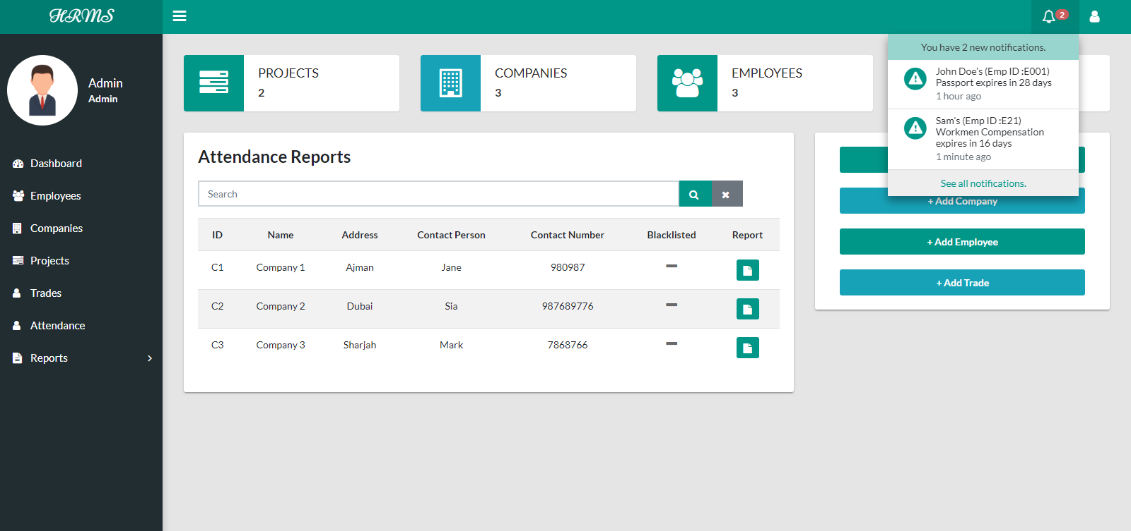

* 1. Notifications

The user can manage notifications here. If a notification is marked as read it will not be shown in the notification icon. If a notification is deleted, it will not be shown anymore in the all notifications.

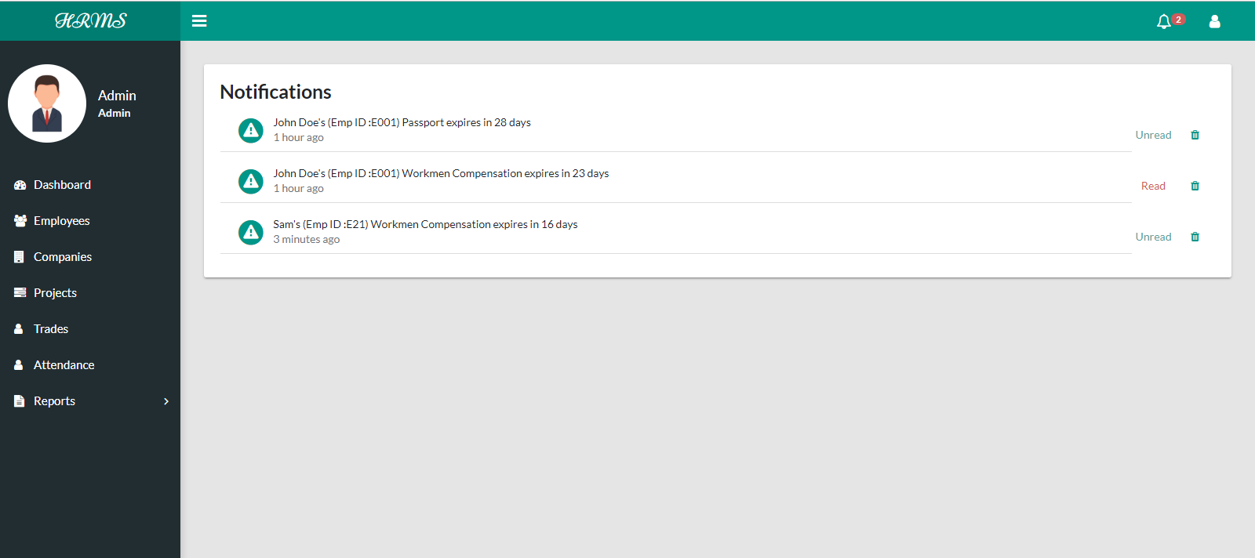

4. Employees

This section will list all the employees that are added by the admin. The admin can add a new employee by clicking on the ‘Add New’ button. He can search for an employee by employee id, name , company or trade. He can view the details of the employee as well as delete the employee. The employee status will be shown as yes or no under corresponding statuses.

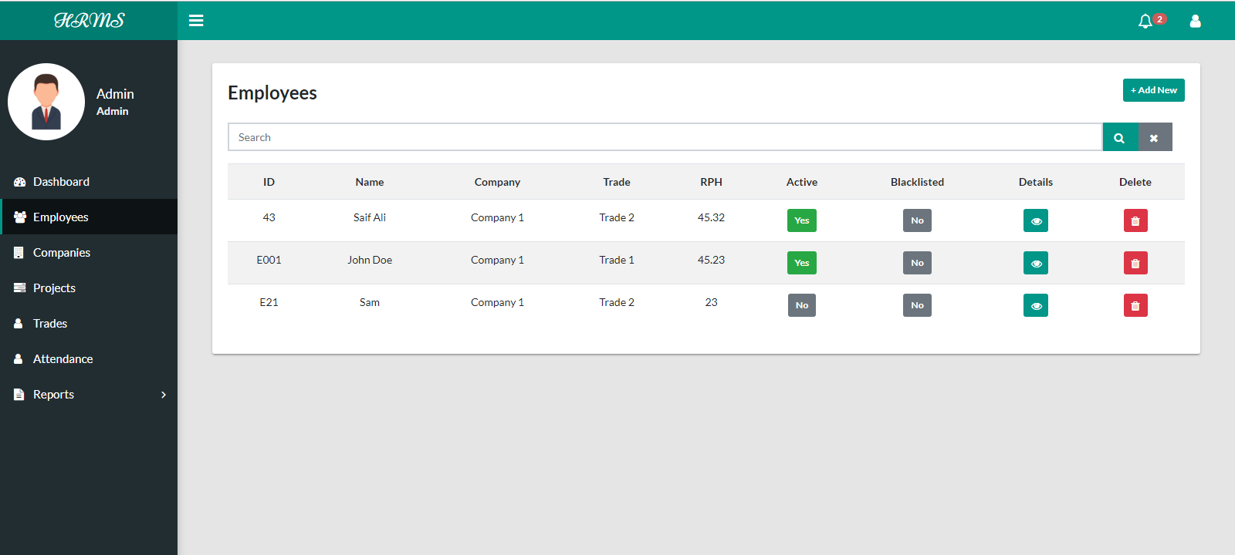

4.1 Add Employee

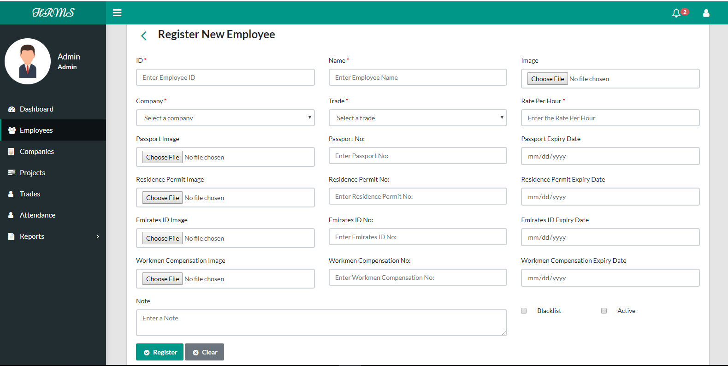

4.3 Employee Details

In this section, the admin can view the documents of the employee by clicking on the eye icon. Also the admin can edit profile of any employee or view the attendace details of the employee by clicking on the corresponding buttons.

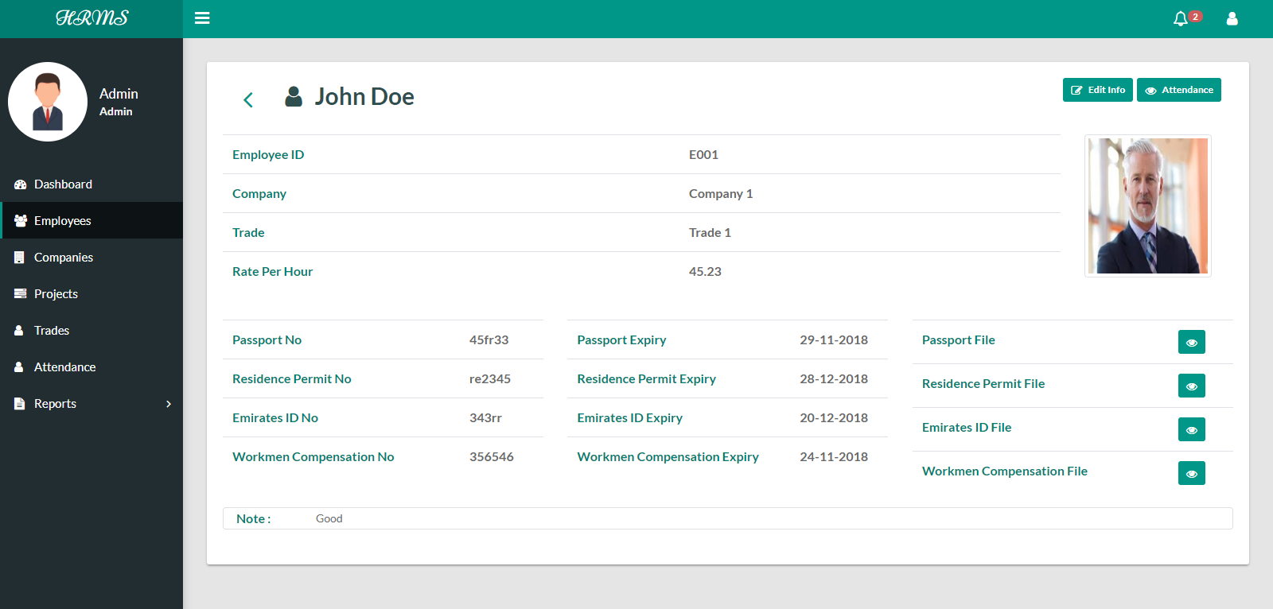

1. Company

This section will list all the companies that are added by the admin. The admin can add a new company by clicking on the Add New button. He can search for a company by any field. He can view the details of the company as well as delete the company. The company status will be shown as yes or no under blacklisted.

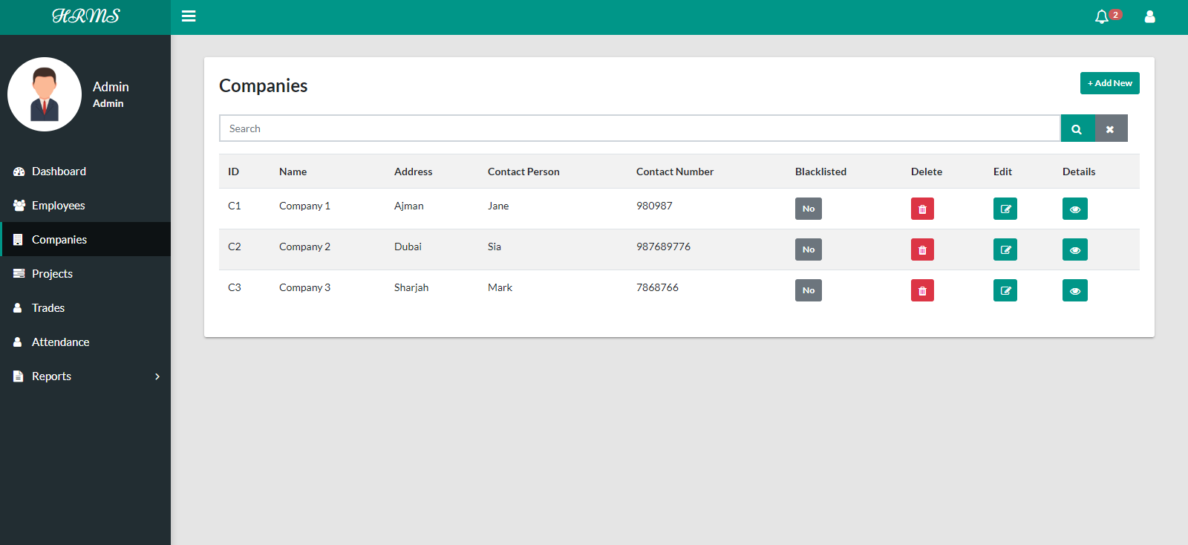

5.1 Add a Company

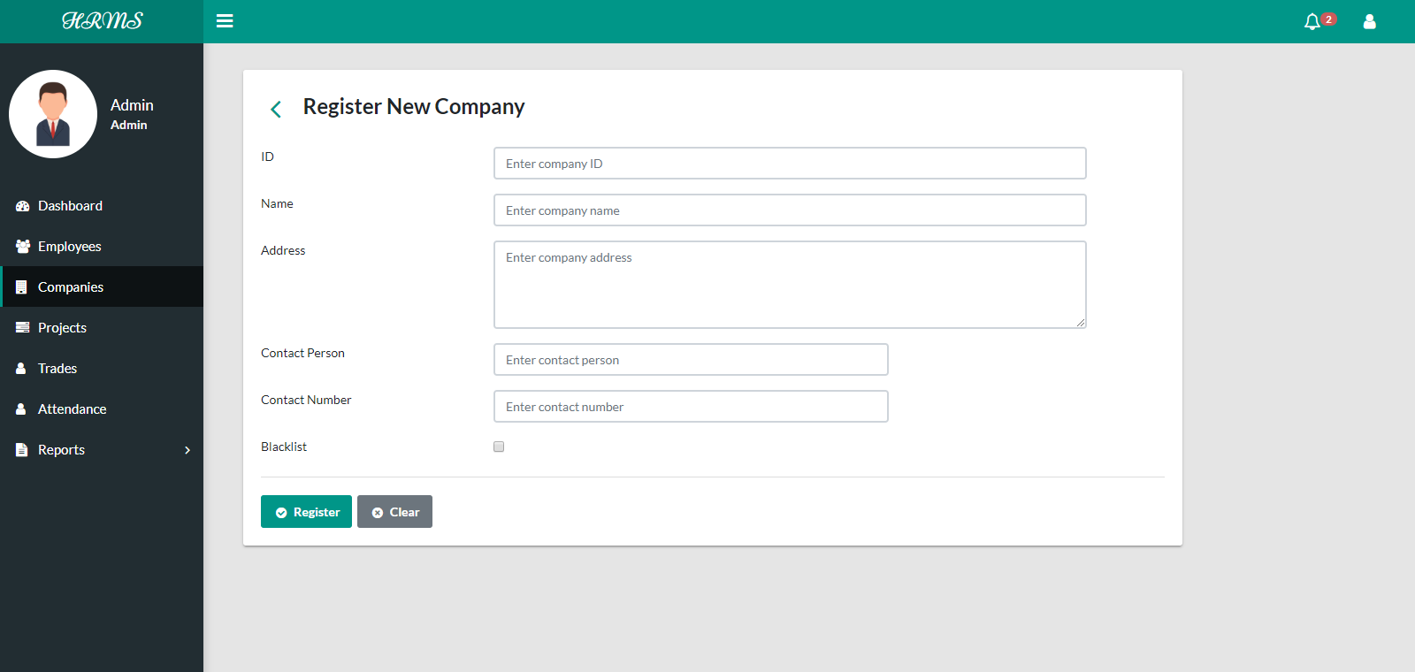

5.2 Company Details

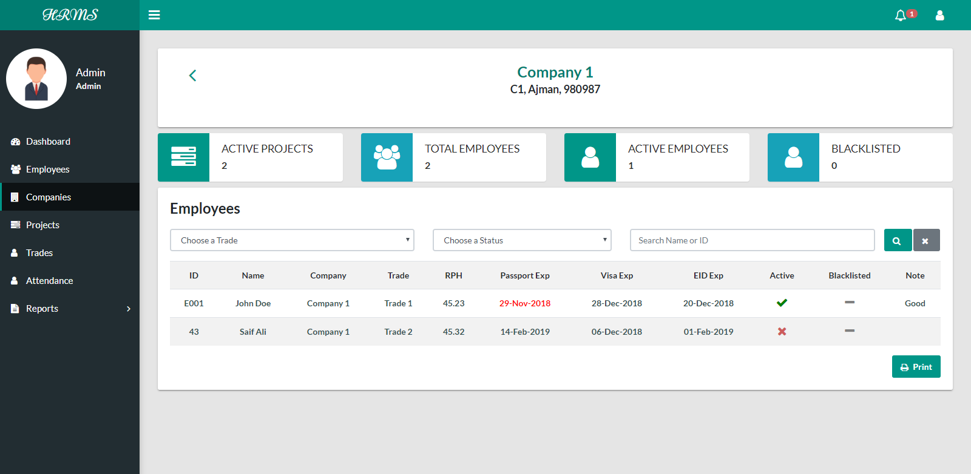

1. Projects

This section will list all the projects that are added by the admin. The admin can add a new project by clicking on the Add New button. He can search for a project by project code, name or location. He can view the details of the project as well as delete the project.

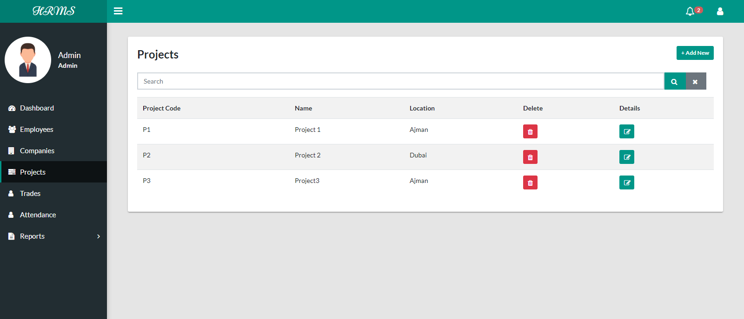

6.1 Add a Project

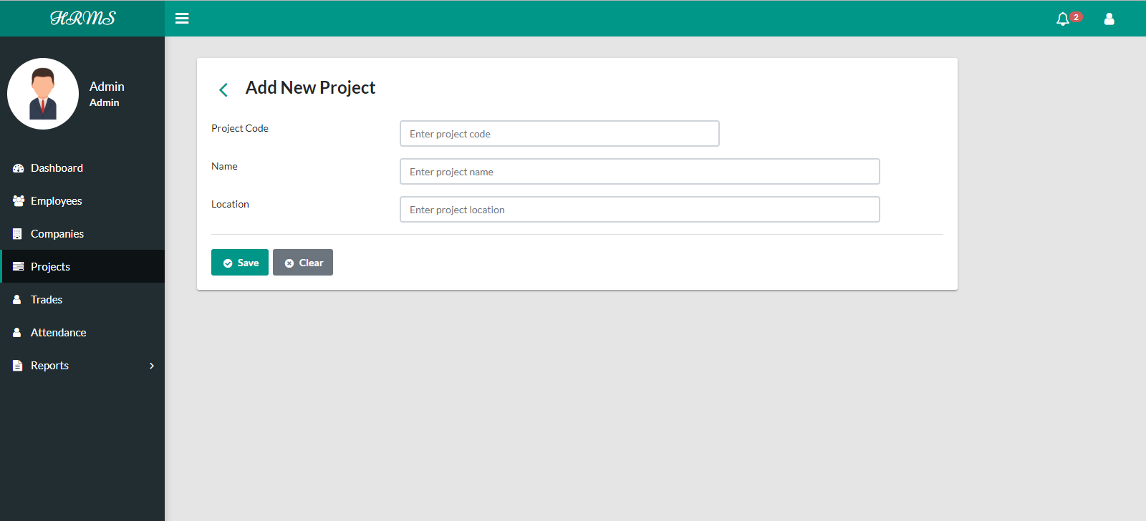

1. Trades

This section will list all the trades that are added by the admin. The admin can add a new trade by clicking on the Add New button. He can search for a trade by trade code or name. He can view the details of the trade as well as delete the trade.

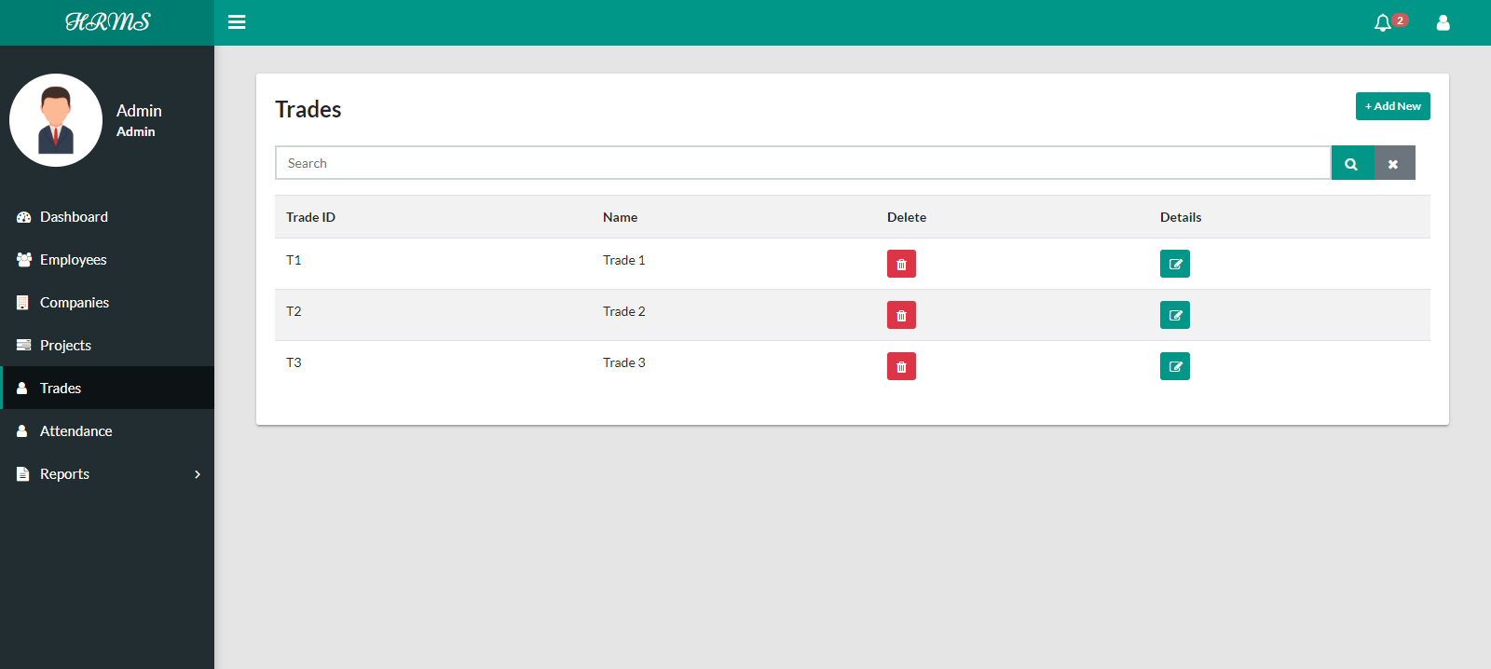

7.1 Add a Trade

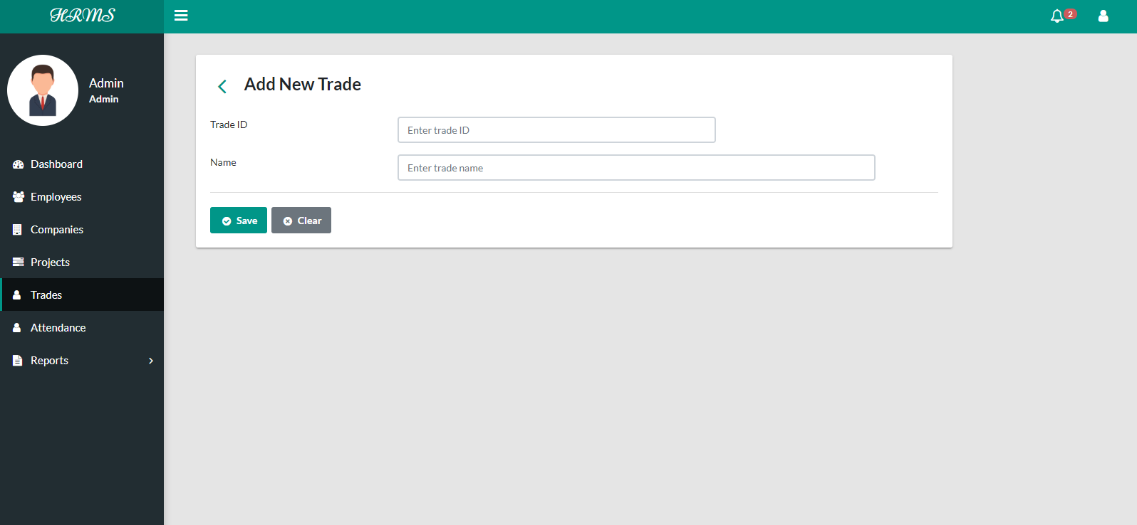

1. Attendance

For marking attendance the admin has to select a company first.

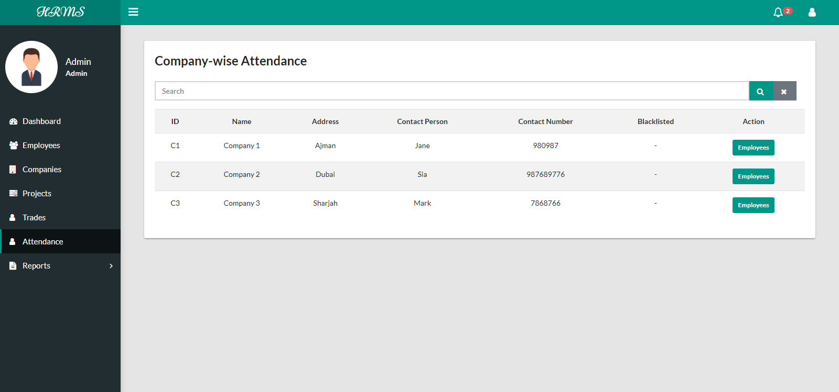

8.1 View Employees for attendance

This section lists all the active employees of a company. Here the admin can select an employee and mark the attendance by clicking on the pen icon or view the marked attendance on clicking the eye icon.

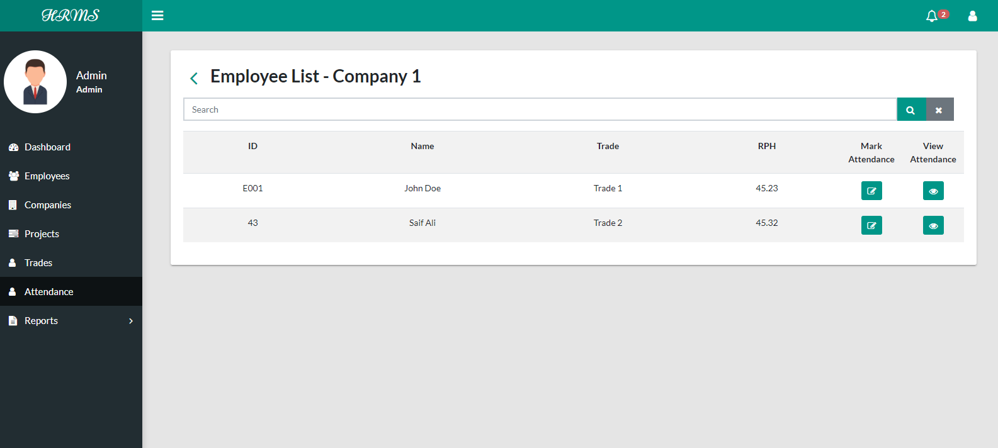

8.1 Set Attendance date

Here the admin needs to set a start and end date of any month at first. After setting this he can mark the attendance of an employee.

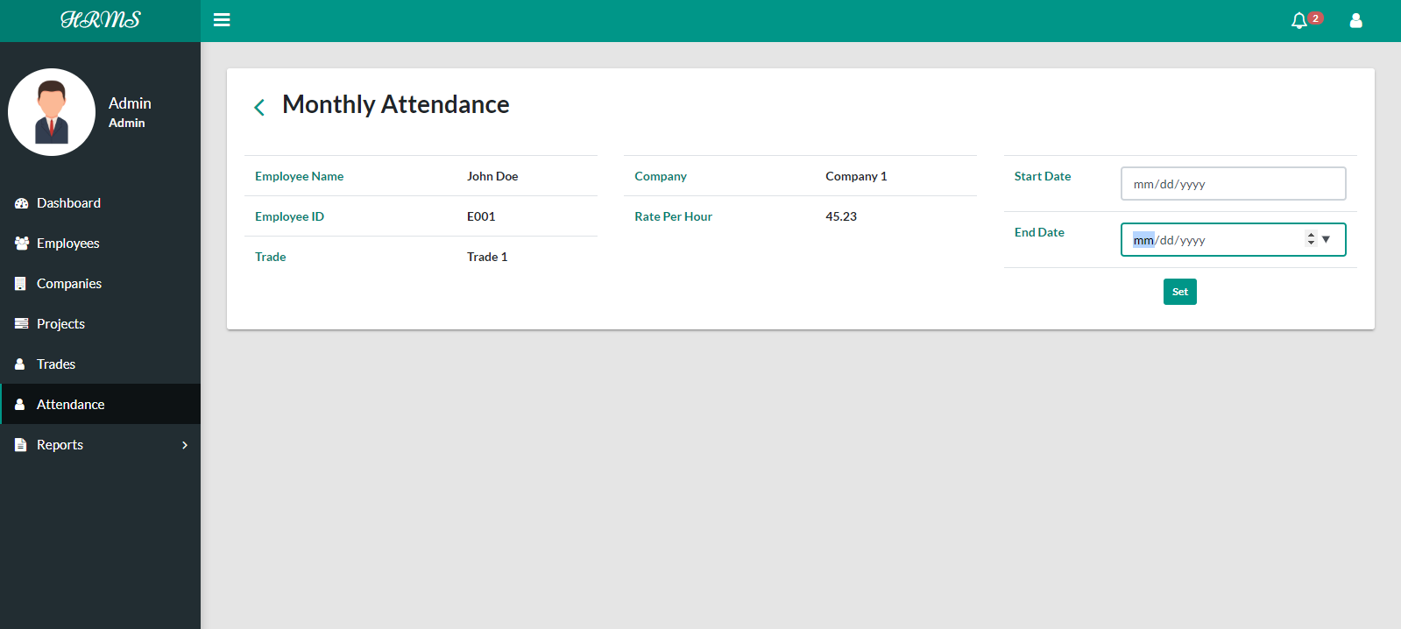

8.2 Mark Attendance

Here, the dates from start to end date will be shown and then admin can add total work hour and the corresponding project of each day. If the admin has already marked a day’s attendance it will be shown as already marked.

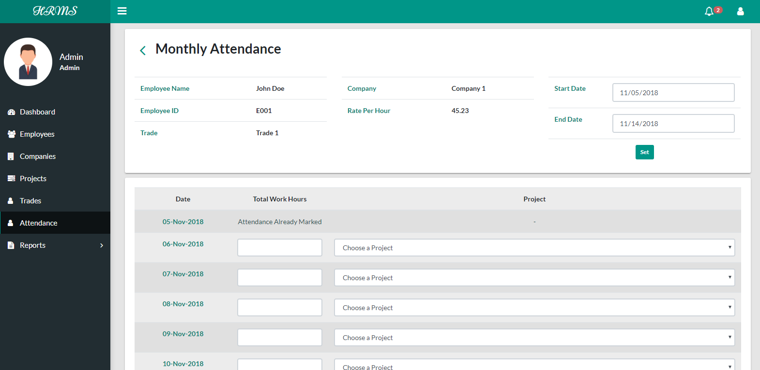

8.3 View Attendance

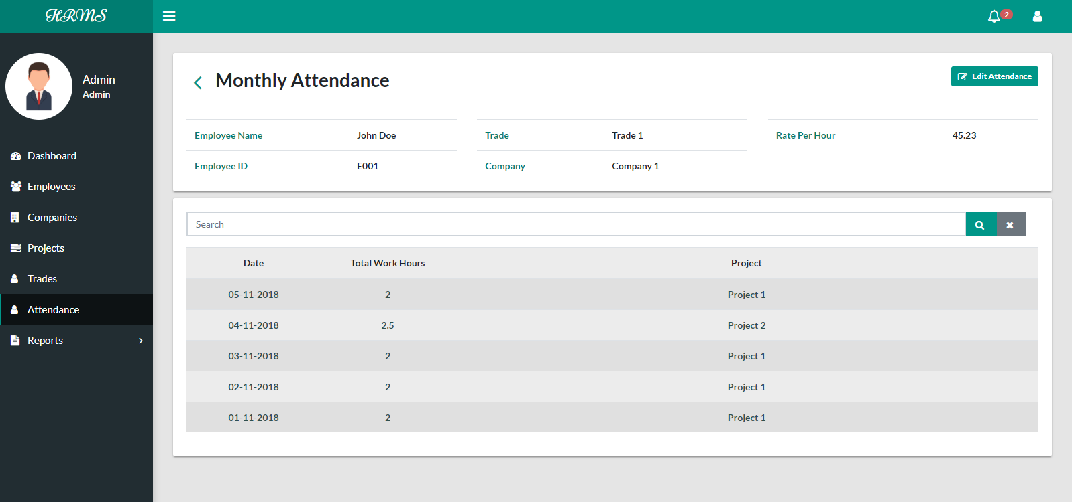

8.4 Edit Attendance

The admin can edit total work hours or project on a date.

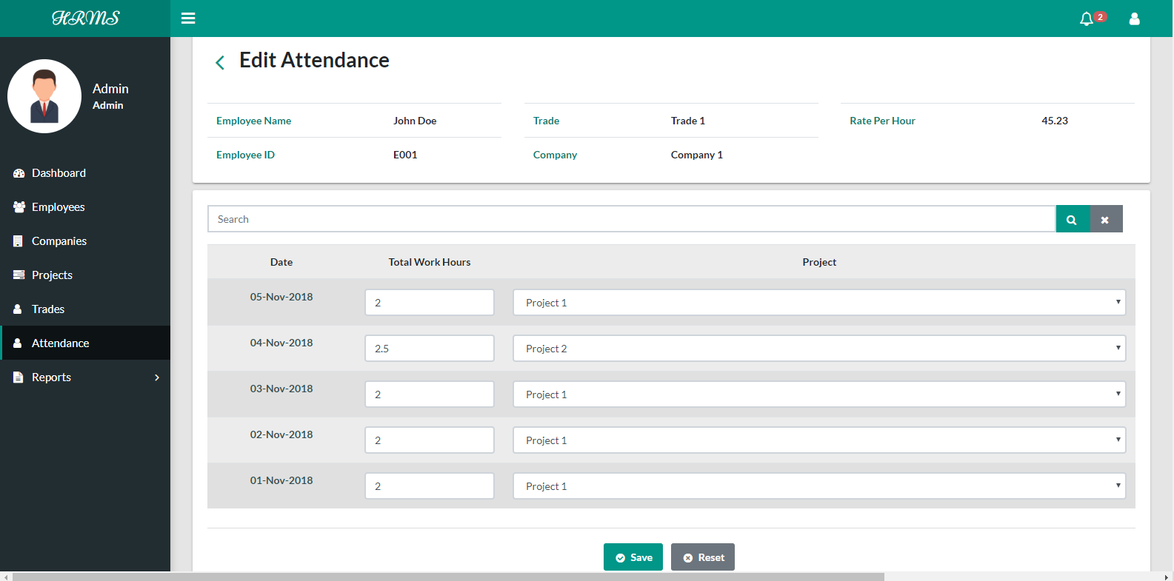

1. Reports
   1. Employee Report

Here, all the employees and their details will be shown. The employee status as active or blacklisted is shown. The admin can search for an employee in the search bar based on any fields. If the admin also add to need a filter to the search by selecting a status, he can click the dropdown and select a status, which shows active, idle, blacklisted and not blacklisted. Also the admin can take the print of the report by clicking on the print button or can save the report as a pdf.

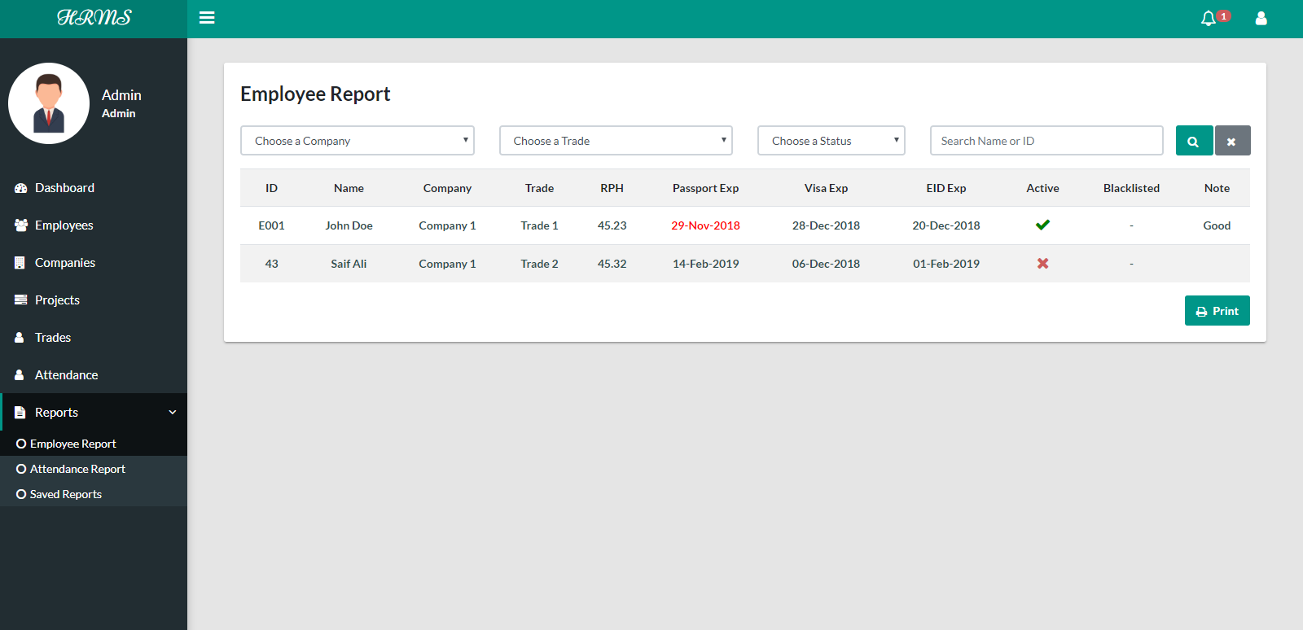

* 1. Attendance Report

The attendance report is company wise, so the admin can view the report of a company.

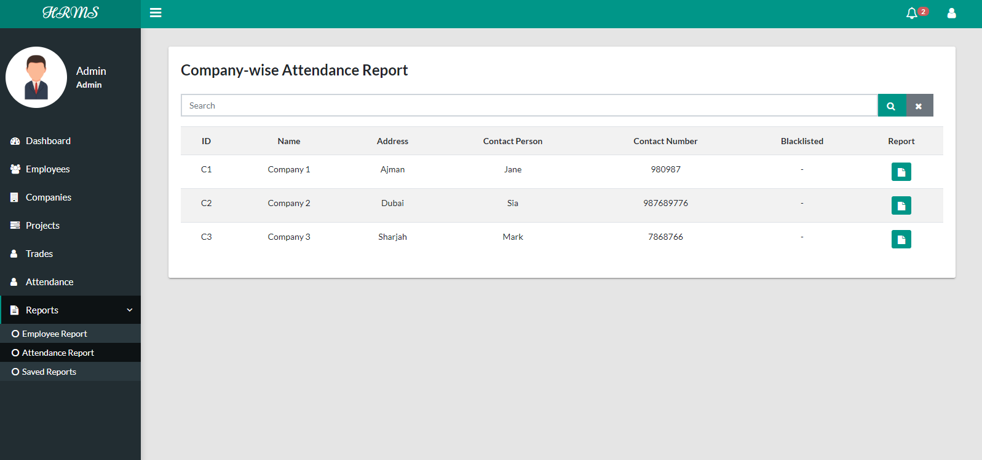

9.2.1 Set inclusive date for Report

The admin needs to select a start date and an end date to view the report.

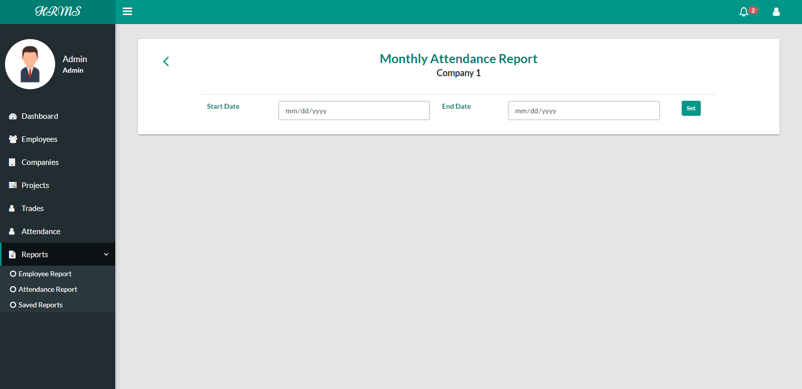

9.2.2 View Report

This section will list all the employees in a company, the projects they have worked on, their total working hours on a project, total working hours on all the projects, and their total amount depending on their rate per hour. Also the admin can take the print of the report or save it as pdf by clicking on the print button.

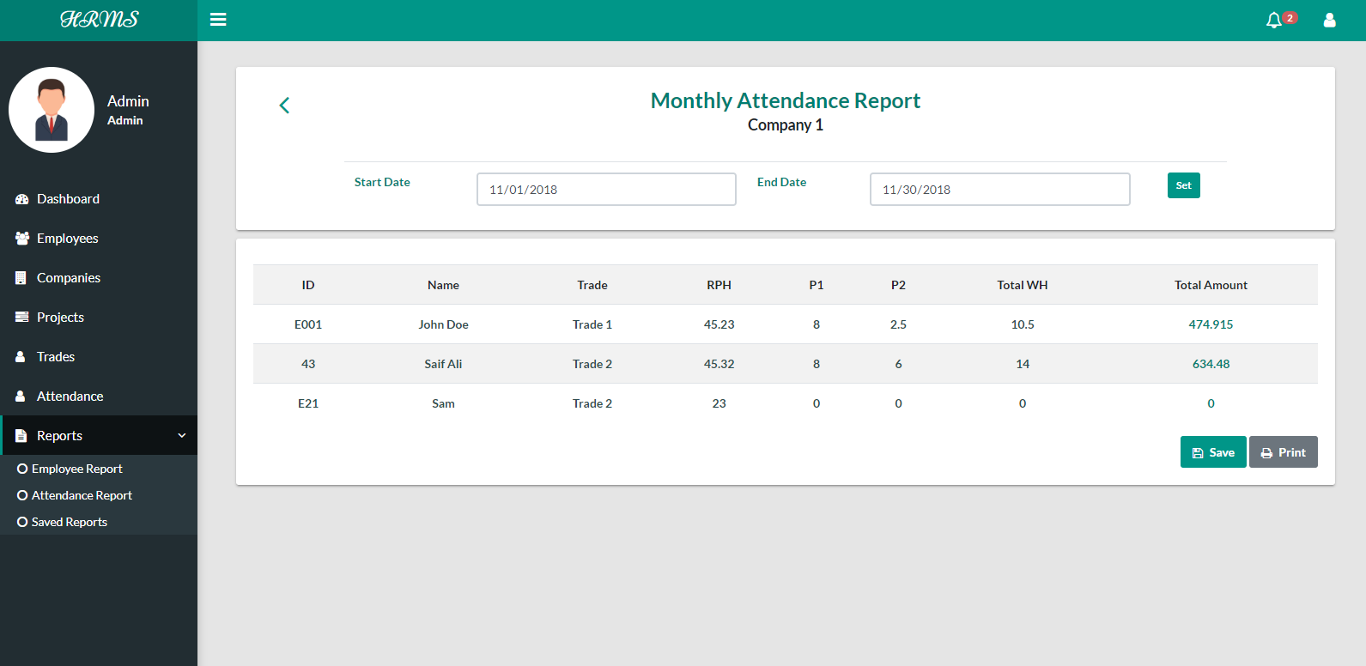

* 1. Saved Reports

Admin has the provision to save a report. This feature helps the admin to add new data without affecting the saved reports. All reports that are saved by the admin will be listed here along with their inclusive dates. The admin can search a report by its date also.

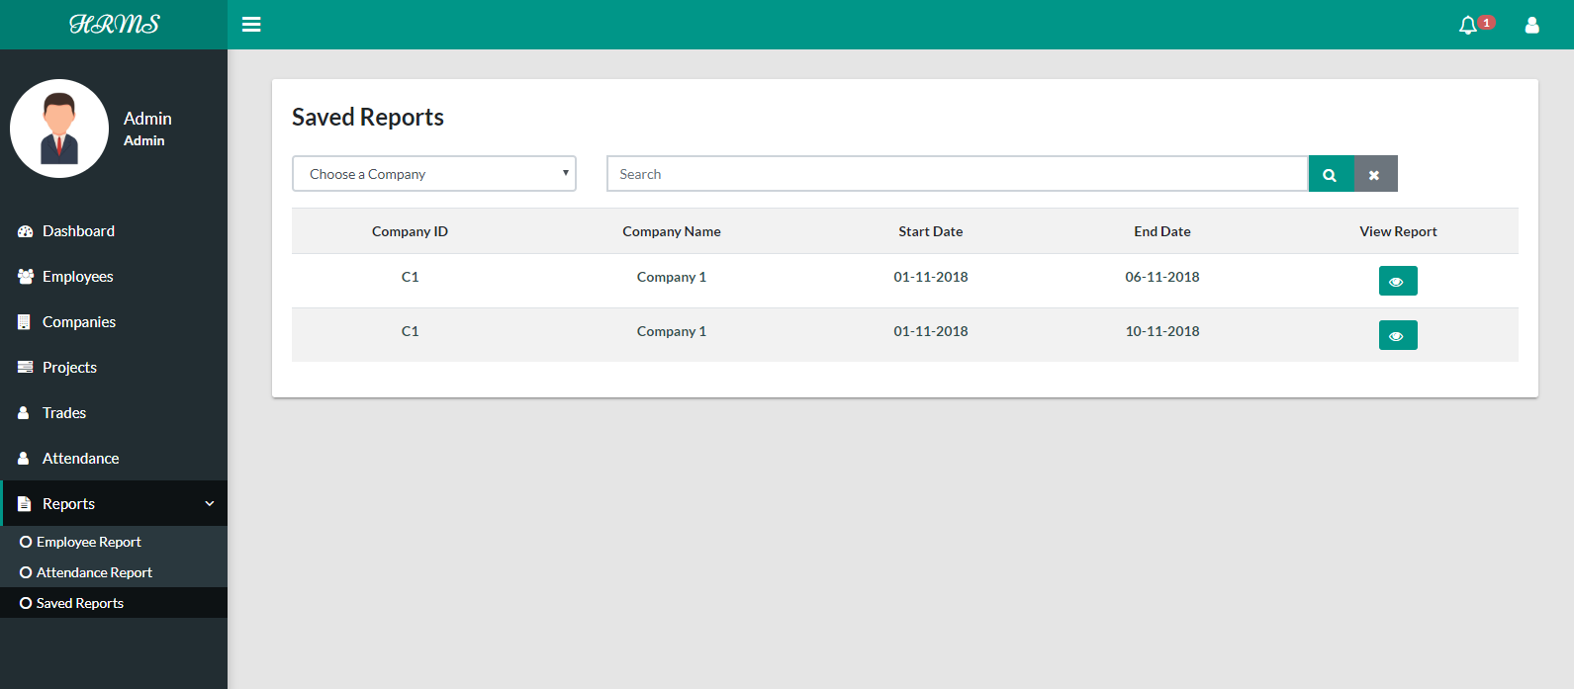

* + 1. View a saved report

In case the admin has to change this report, he can delete this report and create a new report with updated data. Also the admin can print the report and save it as pdf by clicking the print button.

